

Course Title: | Fundamental of Data Engineering
Course Number: | COE848
Semester/Year (e.g.F2016) | W2022

Instructor: | Faezeh Ensan

Assignment/Lab Number: | 3
Assignment/Lab Title: | Database Design

Submission Date : | Feb. 28. 2021
Due Date: | Feb. 28.2021

Student  LAST Name | Student  FIRST Name | Student Number | Section | Signature*
Chen | Rick | 500909131 | 02 | 

*By signing above you attest that you have contributed to this written lab report and confirm that all work you have contributed to this lab report is your own work. Any suspicion of copying or plagiarism in this work will result in an investigation of Academic Misconduct and may result in a “0” on the work, an “F” in the course, or possibly more severe penalties, as well as a Disciplinary Notice on your academic record under the Student Code of Academic Conduct, which can be found online at: http://www.ryerson.ca/senate/current/pol60.pdf
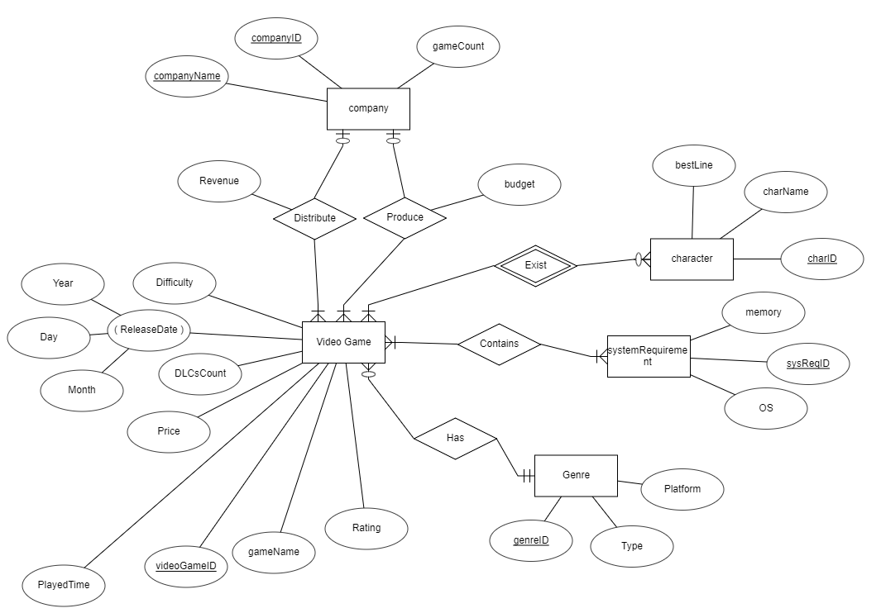
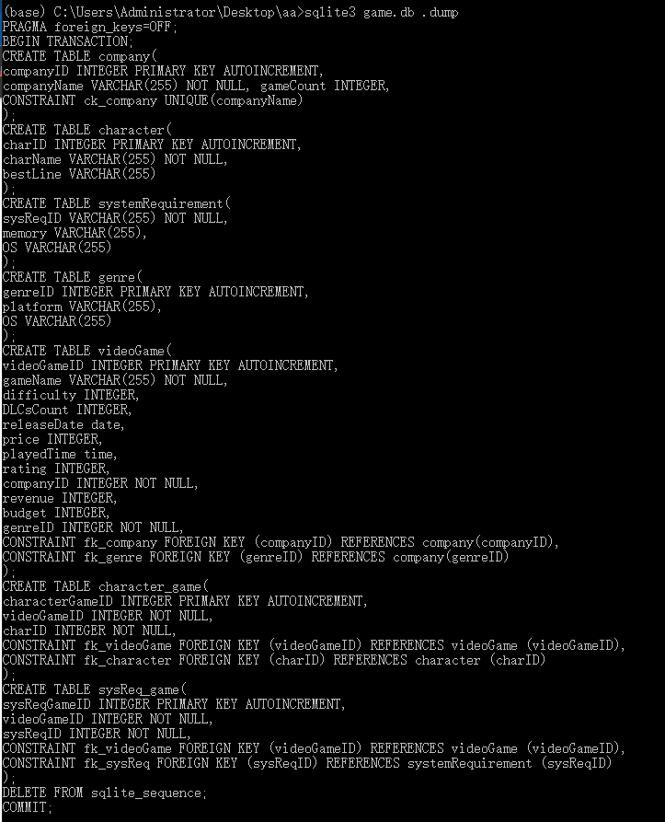

- Entities:
  - company(companyID, companyName, gameCount): The company table has a primary key, companyID, a candidate key, companyName, and gameCount is a regular attribute of the company.
  - character(charID, charName, bestLine): The charID is the primary key of this table, and the charName is a candidate key. bestLine is the attribute for the best line spoken from that character, if any.
  - systemRequirement(sysReqID, memory, OS): The sysReqID is the primary key of this table and the table also has another two attributes, memory and OS.
  - genre(genreID, type, platform): The genre table has a primary key, genreID and two other attributes, type and platform.
  - videoGame(videoGameID, gameName, rating, releaseDate, DLCsCount, price, playedTime, difficulty, genreID, companyID, revenue, budget) : This is the main table of the project. The primary key of the table is videoGameID. One composite attribute, releaseDate composed of year, month and day and has data type of date. The playedTime is another attribute with a unique data type: time. Two attributes of the relationship are revenue and budget. Last, genre and company are the foreign keys of this entity.

- Many to many relationships
  - charcter_game(characterGameID, videoGameID, charID): This table is for the many to many relationship between character and videoGame entity. The table has 1 primary key and 2 foreign keys.
  - sysReq_game(sysReqGameID, videoGameID, sysReqID): This table is for many to many relationships between systemRequirement and videoGames. The table contains 1 primary and 2 foreign keys.

